The Ethiopian Boeing 737 MAX Crash
Institution
Course
Name

Summary
The Ethiopian Boeing 737 MAX took off from Bole International airport in Ethiopia and after six minutes the aircraft crashed near the town of Bishofu which is located 37 miles south-east of the Capital. After investigations were carried out by the investors from the Ethiopian airline and those from FAA, it was settled for the decision that there were issues with the climbing of the plane. According to the data that was retrieved from the black box, it indicated that the pilot named as Senior Capt Yared Getachew had reported of technical issues after some minutes and had requested to land (BBC News, 2019). In addition, according to air traffic Flightradar24, the aircraft’s vertical speed was unstable after it took-off. Thus, the Ethiopian Boeing 737 MAX was believed to have crashed due to a system failure. According to the investigators, there occurred repeated activation of a flight control system that is known as MCASS. The MCASS was said to have responded to the fake signals that were send by the censors which are used to measure the aircraft’s angle of attack. When the MCASS responded to the signals, it dropped down the nose of the plane – which is the front part of the aircraft. When the nose drops down, it indicates that the aircraft wants to land. However, this was wrong since the aircraft was flying and there was no way it could land while still enroute to Nairobi.
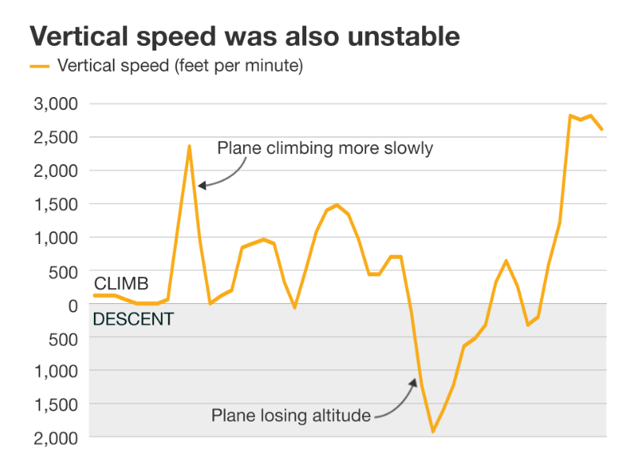
According to the Ethiopian team’s report, it showed that the pilots had carried out all the procedures that were available to enable them to bypass the automated system. They concluded that, once the system got activated automatically, there was a likelihood that the aircraft had high chances of crashing. A former chief engineer with the Boeing 737 MAX, Yonas Yeshanew, claimed that Boeing Company was messing up with the documentation of the condition of the aircraft so that they could get a pass from the FAA. He also added that, the company was carrying out shoddy maintenance. According to the Ethiopian committee which had been assigned to oversee the investigation on what could have led the crash claimed that their pilots were qualified. However, it was found out that the Ethiopian pilots were not carrying out the flight simulator (BBC News, 2019). The flight simulator had been fixed in the airplane two months ago before the plane crashed and it appeared that it had not been used. This could be an indication that maybe the Ethiopian pilots had no expertize that could have helped them in using the flight simulator. Also, it could be concluded that the Ethiopian pilots lacked some skills that could have helped them mitigate cruising risks if they knew how to use the flight simulator.
Determining the Cause of the Accident
According to the committee that was established to carry out investigations about the Ethiopian crash, the airplane started to experience issues about twelve seconds after it took off. It was suggested that there was a likelihood that the airplane could have hit a foreign object in the airspace around the airport. It was suggested that airplane might have hit a bird that was flying over the airport. After the aircraft had hit the bird, it got stuck blocking the airflow heading to a vital sensor (BBC News, 2019). The sensor began to malfunction which later lead to the whole system malfunctioning. The pilots were said to have retracted the flaps after which the sensor once again kicked-off functioning. However, this round the sensor could not function well – instead it began to feed faulty information into the MCASs that was built to help prevent the aircraft from stalling.
According to the committee of experts that was carry out investigations as to what could have led to the crash, the aircraft was taking off at full speed. With there being false commands directed to the aircrafts control system, the nose-down commands kicked-off. It was also pointed out that it was unusual for the aircraft to be taking off while its engine was running at high speed. This meant that there was some issues that could have made the experienced pilots not to be able to control the speed of the engine. In addition, according to veteran US Pilot, it was unusual for experienced pilots to let the airbus take-off with high speed, unless there were some other issues that prevented them from reducing the speed of the engine (BBC News, 2019). After having looked at the report issued by the Ethiopian committee, it was found out that there was no a clear reason why the pilots decided to let the aircraft take-off at full speed. On the other hand, it was pointed out that the pilots had left the throttle at takeoff power because they had earlier intended to let the aircraft continue to climb. Their intentions of allowing the aircraft to keep on climbing were cut-short by the nose-down commands of the MCASS.
Following the report that was issued by Ethiopian Committee, the pilots together with the crew members were unable to intercept successfully commands that were taking place in the MCASS. This made it not an easy task for them to keep the airbus in control. The Chief Executive, Dennis Muilenburg, pointed out that the software flaws that occurred lead to the airbus taking a dive that the pilots could not be in a position to intercept successfully.
Aviation Safety Principles Applied
The committee that was assigned to carry out investigations with regard to the Ethiopian Boeing 737 MAX used four key principles of aviation safety. The following are the four key aviation safety principles that were used:
- Assurance
- Risk Management
- Policy
- Promotion
Risk Management
According to the aviation safety principle, risk management, risk control processes should be geared towards ensuring that the required resources are allocated in order to assist in preventing or addressing the risk that have been identified. Those dealing with the investigation should be allowed to report issues that have been found easily (Stolzer, Halford, & Goglia, 2008). On the other hand, the risk mitigation processes ought to be effective in order to give way for efforts that are meant to stop the issues from continuing to occur. It was found out that the Ethiopian crew staff together with the pilots had tried to override the system but kept on issuing commands that made the system think that the airbus had lost its lift (Boeing, 2020).
Policy
According to the safety principle of policy, the crew members and the pilots should show willingness to fully engage as well as provide their support in order to ensure that there are minimal aircraft crashes (Vistair, 2021). The crew staff and the pilots together with any other partner who might be working hand-in-hand with the pilots to ensure safe fly should show appreciation of the significance of hazard identification as and safety reporting. Following the report by the investigators, it was pointed out that the pilots had not been using the flight simulator despite it having been installed two months earlier before the crash.
Promotion
Promotion safety aviation principle was also used by the investigators who were investigating the Ethiopian Boeing 737 MAX crash. The principle of promotion states that, the management is required to have progressively conveyed safety policies as well as communicating about its objectives (Vistair, 2021). Considering what was found out by the Ethiopian committee, that the pilots were not using the flight simulator, it was an indication that the pilots did not know its function. If the airline’s management had been communicating about the need to have the pilots run the flight simulator, there is a likelihood that maybe they could have avoided the crash.
Assurance
The safety aviation principle of assurance is based upon the fact that risk control measures that have been implemented should be effective. The safety control measures that have been put in place should be reviewed from time-to-time in order to ascertain their effectiveness (Stolzer, et al., 2008). In this case, if the pilots or the crew staff had been running the flight simulator, maybe it could have been easy for them to find out if there were any issues facing the system.

References
BBC News. (2019). Boeing 737 Max: What went wrong? BBC, Retrieved from: https://www.bbc.com/news/world-africa-47553174.
Boeing. (2020). Aerodynamic Principles of Large-Airplane Upsets. Aeromagazines, Retrieved from: https://www.boeing.com/commercial/aeromagazine/aero_03/textonly/fo01txt.html.
BBC News. (2019). Ethiopian Airlines crash: FAA says Boeing 737 Max 8 is airworthy. BBC News Africa, Retrieved from: https://www.bbc.com/news/world-africa-47533052.
Vistair. (2021). The Four Principles of an Aviation Safety Management System. Vistair, Retrieved from: https://resources.vistair.com/articles/-four-principles-of-a-safety-management-system-sms.
Stolzer, A. J., Halford, C. D., & Goglia, J. J. (2008). Safety management systems in aviation. Aldershot, Hampshire, England: Ashgate.

